|  |  |
| --- | --- |
| **SVKM’S NMIMS**  **MUKESH PATEL SCHOOL OF TECHNOLOGY MANAGEMENT& ENGINEERING**  Academic Year: 20-21 | |
| Program: BTech Stream ;Computers | Year: III Semester: V |
| Subject: Web Programming -I | Time: 2 hrs (_5 to_7) |
| Date: 7/ 11 / 20 . | No. of Pages: 2 |
| Marks: 50 |  |
| **Final Examination** | |

**Instructions: Candidates should read carefully the instructions printed on the question paper and on the cover of the Answer Book, which is provided for their use.**

1) **In all __5__ questions to be attempted**.

2) All questions carry equal marks.

3) **Answer to each new question to be started on a fresh page.**

4) **Figures in brackets on the right hand side indicate full marks**.

5) **Assume Suitable data if necessary.**

**ROLLNO:: B032**

**SAPID::70021018030**

1. Create a HTML page with CSS to create the following output. (10)

Use following html tags

p, a, div,img

Use following CSS properties

Background color, padding ,margin, font color, style, size, border color and width.

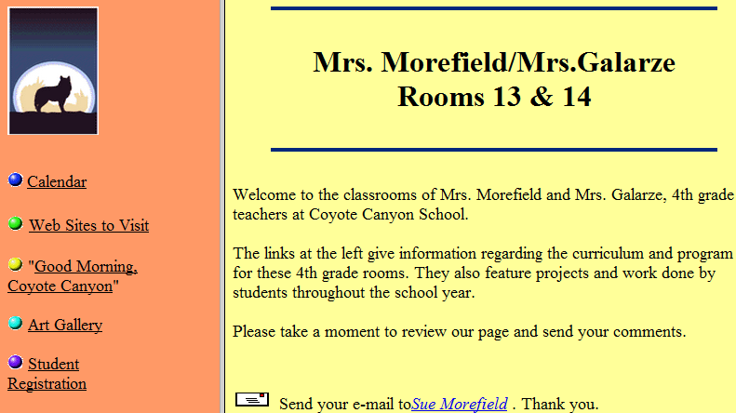

Note: For image use the one given in folder. Note do not create circles in the left div.

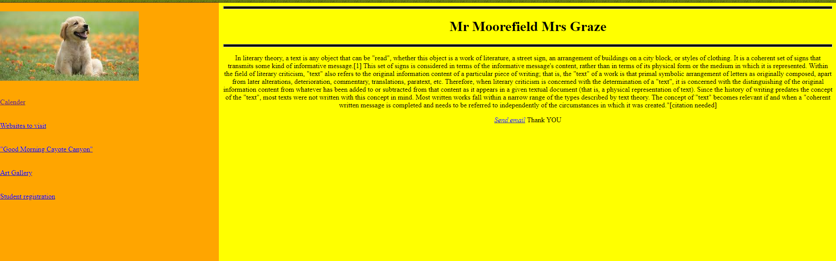

<!DOCTYPE html>

<html>

<head>

    <title></title>

    <link rel="stylesheet" href="1.css">

</head>

<body>

    <div class="sidenav">

    <img src="dog.jpg" alt="DOG"><br><br><br>

    <a href="2.html">

        Calender</a><br><br><br>

    <a href="#" >

        Websites to visit</a><br><br><br>

    <a href="#">

        "Good Morning Cayote Canyon"</a><br><br><br>

    <a href="#">

        Art Gallery</a><br><br><br>

    <a href="#">

        Student registration</a><br><br><br>

    </div>

    <div class="main" text-align: center>

        <hr style="height: 5px;background: black;">

        <h1 >Mr Moorefield Mrs Graze</h1>

        <hr style="height: 5px;background: black;">

        <p>In literary theory, a text is any object that can be "read", whether this object is a work of literature, a street sign, an arrangement of buildings on a city block, or styles of clothing. It is a coherent set of signs that transmits some kind of informative message.[1] This set of signs is considered in terms of the informative message's content, rather than in terms of its physical form or the medium in which it is represented.

            Within the field of literary criticism, "text" also refers to the original information content of a particular piece of writing; that is, the "text" of a work is that primal symbolic arrangement of letters as originally composed, apart from later alterations, deterioration, commentary, translations, paratext, etc. Therefore, when literary criticism is concerned with the determination of a "text", it is concerned with the distinguishing of the original information content from whatever has been added to or subtracted from that content as it appears in a given textual document (that is, a physical representation of text).

            Since the history of writing predates the concept of the "text", most texts were not written with this concept in mind. Most written works fall within a narrow range of the types described by text theory. The concept of "text" becomes relevant if and when a "coherent written message is completed and needs to be referred to independently of the circumstances in which it was created."[citation needed]

            </p>

            <p ><i><a href="mailto:naman@example.com">Send email</a></i> Thank YOU</p>

    </div>

</body>

</html>

CSS::

.sidenav {

  height: 100%;

  width: 500px;

  position: fixed;

  top: 0;

  left: 0;

  background-color: orange;

  padding-top: 20px;

}

body {

  margin-left: 500px;

  padding: 0px 10px;

  background-color: yellow;

}

.main {

  text-align: center;

}

.mail {

  font-style: italic;

}

.circle {

  height: 10px;

  width: 10px;

  background-color: rgb(88, 119, 255);

  border-radius: 50%;

  display: inline-block;

}

1. In the webpage created above, create circles using span tag, using css properties border radius, height, width, display. When clicked on Calendar, go to a new web page called “calendar.html” with table as shown

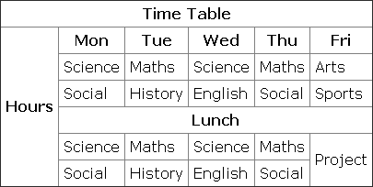

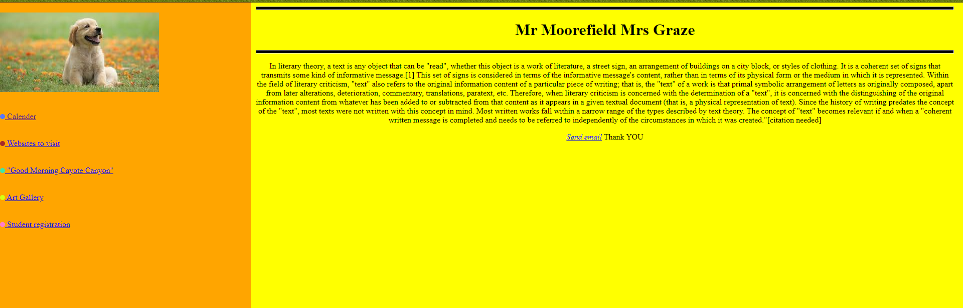

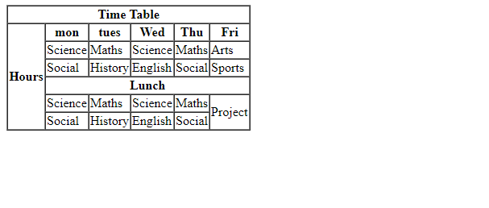

<!DOCTYPE html>

<html>

<head>

    <title></title>

    <link rel="stylesheet" href="1.css">

</head>

<body>

    <div class="sidenav">

    <img src="dog.jpg" alt="DOG"><br><br><br>

    <a href="2.html"><span class="circle"></span>

        Calender</a><br><br><br>

    <a href="#" ><span class="circle" style="background-color:brown"></span>

        Websites to visit</a><br><br><br>

    <a href="#"><span class="circle" style="background-color:rgb(63, 231, 167)"></span>

        "Good Morning Cayote Canyon"</a><br><br><br>

    <a href="#"><span class="circle" style="background-color:rgb(212, 255, 19)"></span>

        Art Gallery</a><br><br><br>

    <a href="#"><span class="circle" style="background-color:rgb(255, 125, 205)"></span>

        Student registration</a><br><br><br>

    </div>

    <div class="main" text-align: center>

        <hr style="height: 5px;background: black;">

        <h1 >Mr Moorefield Mrs Graze</h1>

        <hr style="height: 5px;background: black;">

        <p>In literary theory, a text is any object that can be "read", whether this object is a work of literature, a street sign, an arrangement of buildings on a city block, or styles of clothing. It is a coherent set of signs that transmits some kind of informative message.[1] This set of signs is considered in terms of the informative message's content, rather than in terms of its physical form or the medium in which it is represented.

            Within the field of literary criticism, "text" also refers to the original information content of a particular piece of writing; that is, the "text" of a work is that primal symbolic arrangement of letters as originally composed, apart from later alterations, deterioration, commentary, translations, paratext, etc. Therefore, when literary criticism is concerned with the determination of a "text", it is concerned with the distinguishing of the original information content from whatever has been added to or subtracted from that content as it appears in a given textual document (that is, a physical representation of text).

            Since the history of writing predates the concept of the "text", most texts were not written with this concept in mind. Most written works fall within a narrow range of the types described by text theory. The concept of "text" becomes relevant if and when a "coherent written message is completed and needs to be referred to independently of the circumstances in which it was created."[citation needed]

            </p>

            <p ><i><a href="mailto:naman@example.com">Send email</a></i> Thank YOU</p>

    </div>

</body>

</html>

CSS::

.sidenav {

  height: 100%;

  width: 500px;

  position: fixed;

  top: 0;

  left: 0;

  background-color: orange;

  padding-top: 20px;

}

body {

  margin-left: 500px;

  padding: 0px 10px;

  background-color: yellow;

}

.main {

  text-align: center;

}

.mail {

  font-style: italic;

}

.circle {

  height: 10px;

  width: 10px;

  background-color: rgb(88, 119, 255);

  border-radius: 50%;

  display: inline-block;

}

2.html::

<html>

<body>

<table border=1 cellspacing="0">

<tr>

 <th colspan="6"> Time Table </th>

</tr>

<tr>

 <th rowspan="6"> Hours </th>

 <th> mon </th>

 <th> tues </th>

 <th> Wed </th>

 <th> Thu</th>

 <th> Fri </th>

</tr>

<tr>

 <td> Science </td>

 <td> Maths</td>

 <td> Science</td>

 <td> Maths </td>

 <td> Arts</td>

</tr>

<tr>

 <td> Social </td>

 <td> History</td>

 <td> English</td>

 <td> Social </td>

 <td> Sports</td>

</tr>

<tr>

 <th colspan="5"> Lunch </th>

</tr>

<tr>

 <td> Science </td>

 <td> Maths</td>

 <td> Science</td>

 <td> Maths </td>

 <td rowspan="2"> Project </td>

</tr>

<tr>

 <td> Social </td>

 <td> History</td>

 <td> English</td>

 <td> Social </td>

</tr>

</table>

</body>

</html>

1. Write html and javascript code to create a form with username and checkboxes with values PYTHON, C++, JAVA. If username starts with “x”, validate that checkbox value selected must be only C++. If username has a substring called ”vi” in given string, validate that checkbox value selected must be C++ and JAVA only. If user entered string is a palindrome, checkbox values selected can be PYTHON, C++, JAVA .

CODE:

<!DOCTYPE html>

<html lang="en">

    <head>

    <meta charset="UTF-8">

    <title>Question3</title>

    </head>

    <script type="text/javascript">

        function REV_STR(str) {

            return str.split('').reverse().join('')

        }

        function handleValidation(){

            var UserName = document.getElementById("UserName").value;

            var PY_VAL = document.getElementById('PY');

            var CPP_VAL = document.getElementById('CPP');

            var JAVA_VAL = document.getElementById('JAVA');

            if (UserName==null || UserName=="")

                  alert("User name can't be blank");

            else if(UserName.charAt(0)=='x'){

                if(PY_VAL.checked == false && CPP_VAL.checked == true && JAVA_VAL.checked == false)

                  alert("Validated");

                else

                    alert("select only C++");

            }

            else if(UserName.includes("vi")){

                if(PY_VAL.checked == false && CPP_VAL.checked == true && JAVA_VAL.checked == true)

                  alert("Validated");

                else

                    alert("select only C++ && JAVA");

            }

            else if(REV_STR(UserName)==UserName){

                if(PY_VAL.checked == true || CPP_VAL.checked == true || JAVA_VAL.checked == true)

                  alert("Validated");

                else

                    alert("select something!!");

            }

        }//ive implemented any of the languages are accepted for palindrome names

    </script>

    <body>

        <header">

            <h2>FORM VALIDATION</h2>

        </header>

        <form>

        <table>

            <tr>

                <td>Username:</td>

                <td><input id ="UserName" type="text" name="username" autofocus required /></td>

            </tr>

        </table>

        <strong>Languages -</strong><br>

        <input type="checkbox" id="PY" value="PYTHON">PYTHON<br>

        <input type="checkbox" id="CPP"  value="C++">C++<br>

        <input type="checkbox" id="JAVA"  value="JAVA">JAVA<br><br>

         <input type="submit" text="submit" onclick="handleValidation()">

         </form>

    </body>

</html>

OUTPUT

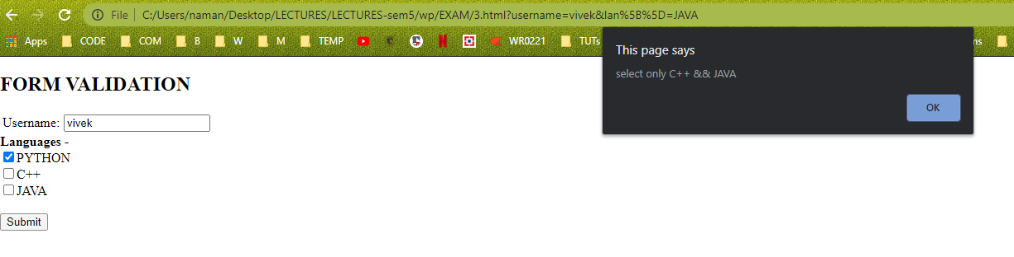 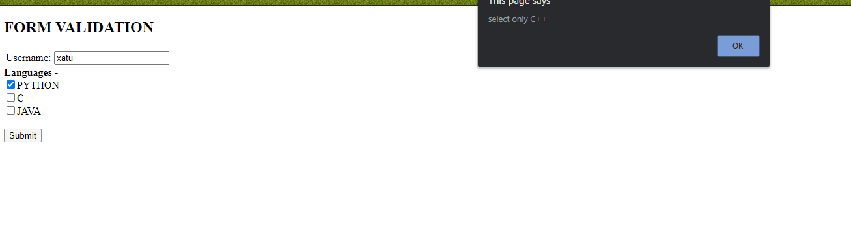 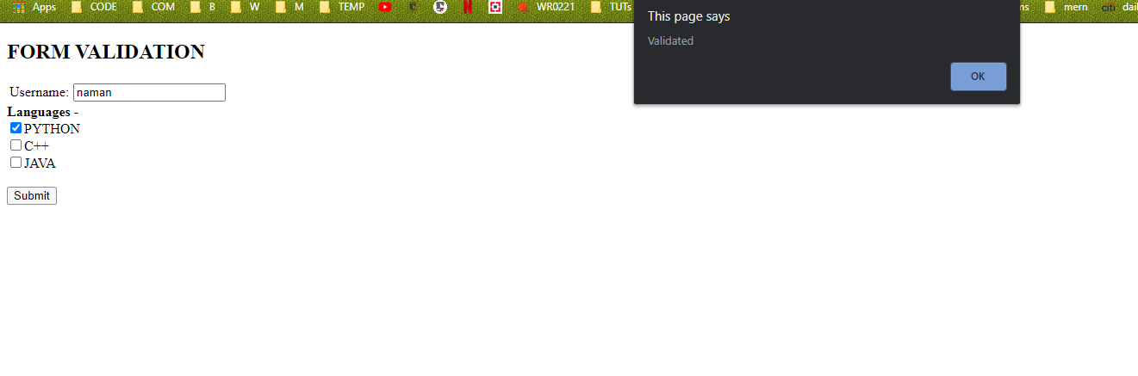

1. Write PHP code to implement a very old encryption algorithm called monoalphabetic encoder.

Example: NBAJYFOWLZMPXIKUVCDEGRQSTH is a totally random alphabet with the 26 letters of the Latin alphabet. **(You need to generate this random string of 26 alphabets)**

And then:

Plain alphabet ABCDEFGHIJKLMNOPQRSTUVWXYZ

Substitution alphabet NBAJYFOWLZMPXIKUVCDEGRQSTH

The substitution involves a replacement of the plaintext of all the letters of the first row with the letters associated with the second row.

Example :DCODE now becomes “JAKJY”(This should be the output)

<!DOCTYPE html>

<html lang="en">

  <head>

    <meta charset="UTF-8" />

    <title>Question4</title>

  </head>

  <body>

    <form action="http://localhost/exam/Q4.php" method="post">

      <input type="string" name="val" placeholder="Enter any string to encode"/>

      <input type="submit" value="submit" name="submit"/>

    </form>

  </body>

</html>

//PHP FILE

<?php

if(isset($_POST["submit"])) {

    $usrVAL = $_POST["val"];

    $count1 = 65;

    $count2 = 97;

    $encryptKEY = "";

    for($i=0; $i < 26; $i++){

        $temp = rand(65, 90);

        $encryptKEY .= chr($temp);

    }

    for($i=0; $i < strlen($usrVAL); $i++){

        if(ctype_upper($usrVAL[$i])){

            $temp = ord($usrVAL[$i]);

            $temp = $temp - $count1;

            echo $encryptKEY[$temp];

        }

        else{

            $temp = ord($usrVAL[$i]);

            $temp = $temp - $count2;

            echo $encryptKEY[$temp];

        }

    }

    echo "  is the encrypted for ";

    echo $usrVAL;

}

else

    echo "Error";

?>

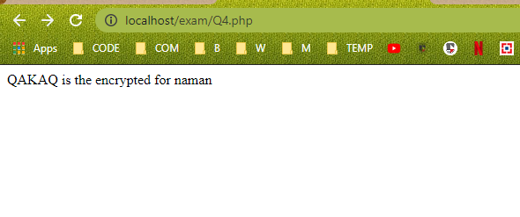

New string each time.

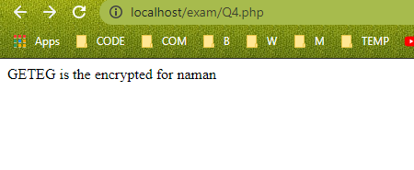

1. Write html code to create a login form with Username, password . Write PHP code to authenticate the username details with database table called user that has columns username, password, no of visits. If valid, create a session for the user and initialize session variable with username and update no of visits column. The display the following message

Welcome username

This is your ________visit

<!DOCTYPE html>

<html lang="en" class="content">

<body>

<form style="text-align: center" action="http://localhost/exam/LoginUser.php" method="post">

    <label for="username">Username </label>

    <input type="text" name="username" id="username" autofocus required/><br>

    <br>

    <label for="password">Password </label>

    <input type="text" id="password" name="password" required>

    <br>

    <input type="submit" name="submit">

</form>

</body>

LoginUser::

<?php

if(isset($_POST['submit'])) {

  $user = $_POST["username"];

  $pass = $_POST["password"];

function OpenCon()

{

    $dbhost = "localhost";

    $dbuser = "root";

    $dbpass = "123456";

    $db = "PHPLecture";

    $conn = new mysqli($dbhost, $dbuser, $dbpass, $db);

    return $conn;

}

function CloseCon($conn)

{

    $conn -> close();

}

 $conn = OpenCon();

 if($conn === false){

    die("ERROR: Could not connect." . $conn->connect_error);

    echo "<br>";

}

$sqlauth = "SELECT password FROM user where username='$user'";

$result = $conn->query($sqlauth);

if($result)

{

if ($result->num_rows >0) {

    $row = $result->fetch_assoc();

    if ($row['password'] == $pass){

    session_start();

    $_SESSION["username"] = $user;

    header('location:welcome.php');

    }

    else{

        echo "invalid password";

    }

} else {

  echo "USER NOT FOUND";

}

}

else

{

    echo "ERROR".$sqlauth."<br><br><br>".$conn->error;

}

CloseCon($conn);

}

else{echo "failed to conn";}

?>

Welcome::

<?php

session_start();

if(isset($_SESSION["username"]))

{

  $user = $_SESSION["username"];

function OpenCon()

{

    $dbhost = "localhost";

    $dbuser = "root";

    $dbpass = "123456";

    $db = "PHPLecture";

    $conn = new mysqli($dbhost, $dbuser, $dbpass, $db);

    return $conn;

}

function CloseCon($conn)

{

    $conn -> close();

}

 $conn = OpenCon();

 if($conn === false){

    die("ERROR: Could not connect." . $conn->connect_error);

    echo "<br><br>";

}

$sql = "SELECT visits FROM user where username='$user'";

$sqlupdate = "UPDATE user SET visits = visits+1 WHERE username='$user'";

$result = $conn->query($sql);

if($result)

{

if ($result->num_rows >0) {

    $conn->query($sqlupdate);

    $row = $result->fetch_assoc();

    echo "HELLO ". $user;

    echo "<br>";

    $viscount = $row['visits']+1;

    echo "this is your ". $viscount . " visit";

} else {

  echo "Not Found";

}

}

else

{

    echo "Error in ".$sql."<br>".$conn->error;

}

CloseCon($conn);

}

else{echo "FAIL";}

session_destroy();

?>

 